GRADE ONE AND TWO
SEPTEMBER HANDBOOK

Hello CCA Families,

We are excited for this new 2015-2016 year at Cochrane Christian Academy! I am a part of the family at CCA and I am very thrilled to be teaching the grade 1/2 class again. I have taught in the public and the private system previously. Two years ago I got married on July 03, 2013 and we enjoyed our honeymoon destination in Hawaii. The purpose of this newsletter is to share some information about classroom routines and my teaching philosophy. I cannot wait for this year at CCA and the relationship we will build! God Bless.
Teaching Philosophy

- The student’s needs (emotional, intellectual, spiritual and physical) always come first.
- I believe classroom community is crucial to a fun learning environment.
- I believe students learn in different ways and I am to facilitate that.
- I believe that it is important for students to be actively involved in their learning and develop as a critical thinker.
- I believe communication is key to success, by giving students the tools to respectfully communicate with others and having open communication with you – the parent.
This list reveals only part of my heart for this upcoming year together, and I cannot wait to get to know you and your family more!

! IMPORTANT for the first week of school!
In the first week of school we will be getting to know each other a little better. On Friday they can bring in one special thing about them. In the second and third week the students will go on an adventure with Tintin. You may encounter pirates and Tintin at your home if you are lucky. If you would like to participate by leaving notes around the house, sea shells, sand, or make a big mess in one of your rooms, that would make a good connection for students to discuss what happened at school.
Students are ONLY released to adults at the end of the day. If they are taking the bus, they are not allowed to go on a different bus other than their designated bus, unless you call and talk with Southland Bussing and make arrangements (Southland bussing: 403-932-7100).

Please have your student bring in a pair of headphones, 2 kleenx boxes, and a memory stick for their work on the computer. The USB is a great way to share their hard work with you at home.

**** School times have changed to: 8:10 – 2:30 from Monday to Friday ****

** Please send me your email address as soon as possible (via email, agenda, or a phone call) so I can send out electronic copies of updates and forms rather than wasting paper. Thank you. **
(Please send back the envelope with the permission forms – ALL of them must be signed and returned for your child to go on field trips or use the Internet. The Rocky View CCA Website has a PLONE page that can open the communication at home about their day at school, Bible memory verses, Word Sort examples, volunteer opportunities, and important documents throughout the year).

Ms. Wiwcharuk is teaching Music and Health this year.
Communicating With Me
If you have any concerns or questions please feel free to send me an email: jbeauparlant@rockyview.ab.ca. I will respond within 24 hours of your email, unless it is the weekend, I will not respond until Sunday. I also have an open door policy in the classroom, however if you can arrange a time before or after school rather than dropping in is preferred. As well, if you have a quick question that does not require a meeting, you can write it in your child’s agenda. My classroom number: 403-932-5177 ext. 6958.
*** If they are ABSENT please call or email the school, not me, so they can change it to excused***

Morning Routines
This is a new process for CCA:
- Parents and students must wait outside of the building.
- Students will line up at their designated door at 8:00 A.M.
- I will come meet them at the door to begin SPARK (a program designed to enhance their daily physical activity and get them ready for learning).
- SPARK will occur between 8:10-8:25 so please dress them for the weather.
- At 8:30 they will put their things away and come to the carpet for devotions
- After devotions we will start with their morning duotang work.
- The students will need to look at the ‘Helping Chart’ to see if they are a helper that day. This will rotate fairly so everyone gets a turn unless they are absent.
***** If a child is LATE they MUST get their agenda signed at the CCA office before coming into the classroom, and if they have lost their agenda, it will cost $7 to replace***** (we are not doing paper late stamps anymore)

Agendas
Please remember to check your child’s agenda every day. I ask that there be a parent signature in the agenda after each day if there is a message. There will only be a few items written down, but it is a good habit for your child. I do use the agendas to write down any tasks the student may have for that evening (ex. Counting how many squares there are in their room). The tasks are small and I need your support at home to continue your child’s learning, as it relates to in-class learning.

Blog
We will have a classroom Blog so you can view your child’s work and the work of the students in the classroom. You will receive an email with the Blog information and password by the end of September.
Lunches and Snacks
In health we discuss healthy choices and what the human body needs, therefore I encourage students to eat their main dish first at lunch and then they can have their treats last. I encourage you to pack healthy snacks for your child, such as fruit, cheese, crackers, veggies, and granola bars. After lunch I will have daily helpers to clean up with me, which will rotate. Please make sure they have proper clothing for the weather and indoor shoes for gym.

Water Bottles
I have a water bottle bin in the classroom for students to keep their water bottles over the course of the week and bring it home for cleaning on Friday. It is very important for students to stay hydrated, helps with brain stimulation, and it reduces the amount of time they spend going to get a drink of water outside of the classroom. Please label their water bottle so there are no mix-ups with similar water bottles.

Bathroom Routine
Students will need to sign in and out of the classroom to go to the restroom using their agenda. At the beginning of the year, students will go in pairs. There will only be allowed one pair in the restroom at a time. We will also have designated bathroom times before recess/after snack and before lunch. Students are to try to go to the bathroom before returning to the classroom after lunch.

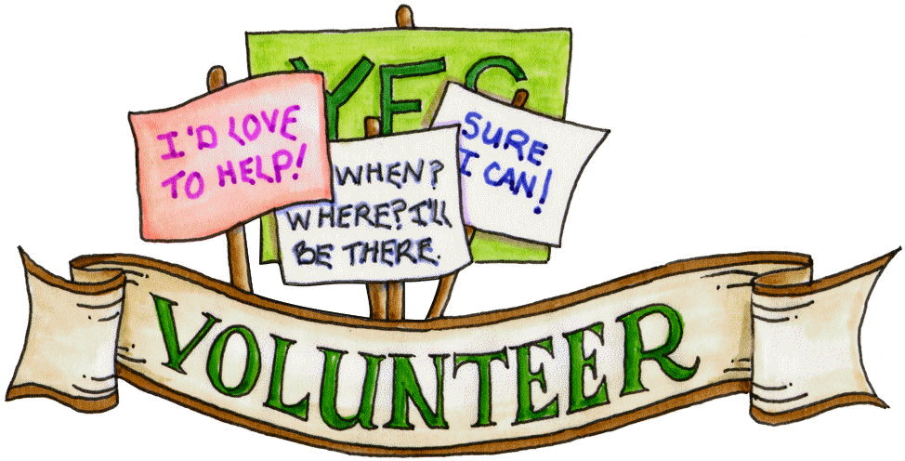
CALLING ALL PARENTS THAT CAN VOLUNTEER
I am looking for parent volunteers to help within the classroom. I will have a sign up sheet on the BBQ night and a schedule posted on PLONE. When you come in to volunteer, you can expect to photocopy, putting together centers, bulletin board work, reading with students, helping prepare materials for art projects, going on field trips, and things of this nature. You must have your Criminal Record Check completed to volunteer at the school or on field trips. Volunteers are the heart of a community classroom and I cannot express the joy it brings the students to see how adults can be involved. I really appreciate parent volunteers!
*** I need three volunteers that can commit weekly. Specifically for an hour or so to organize and prepare the Reading A-Z books, mark comprehension sheets for Reading A-Z, and word sort preparation.

Home Reading Program and Learning Commons/Library Program
The Grade Ones and Twos will be participating in a home reading program using photocopied books from ‘Reading A-Z.’ The students will be sent home one-three books and one comprehension sheet each Wednesday. They must return the books and comprehension sheet by the following Tuesday. I will send these books home in a zip-lock bag and would appreciate if you help your child return it in the same condition please.

Also, students will go to the Learning Commons/Library once each six day cycle and can take two books out. This year CCA is working on a six-day cycle and our Learning Commons time is to be announced via email. I will remind the children the day before our Learning Commons day so they can return their books on time, and I would suggest writing in the due dates on a calendar or in their agenda each week.
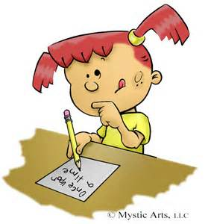
Homework
This is a way for you to be involved in your child’s learning and become aware of the learning happening in the classroom. Generally, I give small tasks to students to accomplish each night. They will be given a writing notebook to complete the homework in each night, and for each completed homework assignment they will be given a sticker. When they have 40 stickers they can come receive a prize from me. There are the odd days that your child will need to research a topic or question at home. The homework will be checked every day after the daily review books – usually in the morning after devotions.

These are the evening Homework Tasks:
- Word Sorts (no more than 5-10 minutes – set a timer)
- Reading A-Z books & complete comprehension sheet (very important to help student development in literacy – 5 minutes to read a book together)
- Agenda homework (5 minutes or less)
All together spend between 15 - 20 minutes an evening. Each child will receive a ‘homework’ notebook to complete the agenda homework and the word sorts. Also they can doodle within for fun, but please limit them to a page an evening and use each side.

Spelling
This year CCA will be continuing with the ‘Words Their Way’ program. After each child’s spelling skills are evaluated, they will be given weekly lists tailored to their individual learning development. This program does require 5 minutes each evening of sorting, but please ensure they are NOT spending more than 10 minutes to complete this task. More information will be provided during the next few weeks from CCA to help you gain greater understanding into this innovative and differentiated spelling program.
PLEASE LET ME KNOW ASAP IF YOU CANNOT PRINT OFF THE WORD SORTS.
We are also using a new spelling website called, Spelling City to practice the word sorts – and can be used as a way of completing a word sort that evening (spellingcity.com). You will know when the students are ready to start this at home when you start receiving the word sort emails.

Bible Memory
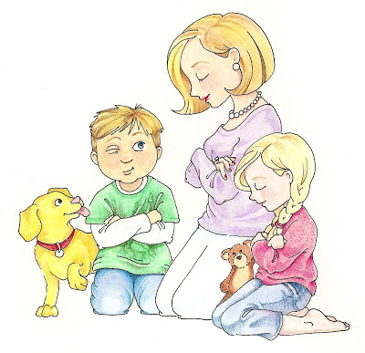
The children will be provided with a series of Bible verses that relate to the topics of study in their Bible program. Each week they will be given the opportunity to practice and memorize one Bible verse. They will receive a check mark on a chart if they are successful. At the end of the year they will be rewarded with an award if they are successful in memorizing all of the assigned Bible verses. Please practice the memory verse at home. They are evaluated in different ways throughout the month (fill-in the blank, verbal, and rearranging are a few). If a child gets their memory verse that day they will receive a happy face on their agenda (another reason it is very important to bring their agendas every day).

Prayer
Please keep the children and myself in your prayers this year. I am so blessed to be covered in prayer and truly believe it makes a huge difference in the classroom.

Mathletics
This is an online math website that CCA uses, which helps students to practice their math skills at home. It gives online support, direct feedback, and provides steps to achieving the correct answer. The students will be sent home with a copy of their Mathletics code within the first two weeks of school. I will provide more information to anyone that needs it on this fabulous program. (http://www.mathletics.ca).

Spelling City
This is an online spelling site that focuses on the word sorts through games. They will have weekly assignments to complete in class and at home.

Weekly Star Time
Each student is very important to me, and I think it is important to learn more about him or her. I randomly draw a name from a jar and that student is our “Weekly Star” for one week. I send home a duo-tang with them so you know what to expect each day for your child. They will also be my special helper for the whole time. At the end of the week the class will make a book for the student to keep as a memory. I do need the duo-tang to be returned to the classroom for the next daily star. On the special lunch day, please email me if you plan on coming into the classroom so I can have a place for you prepared.

Birthdays
Birthdays are a special time for the students and we recognize each child on their birthday. If you would like to do something special for your child on their birthday please email me. I can let you know if there are any food allergies or dietary needs. Summer birthdays will be celebrated within the month of June.

Bimonthly Updates
A classroom is a busy place, but I think it is important for you to be involved in your child’s learning. I will make the effort to send out bi-monthly updates via email and the availability of the Blog. The updates will also be posted onto the CCA PLONE teacher page. Each month we will be focusing on different 21st Century Learning Competencies, that will be updated on my PLONE page.
Steps to getting onto PLONE:
- Go to http://cca.rockyview.ab.ca/
- Click on Elementary and then Mrs. Beauparlant Grade ½
- You are now on my site to view Calendars, Volunteer Schedules, Handouts, and Helpful Websites.

Special Days
I believe that having special dress-up days are important to classroom bonding. All ‘special days’ will be related to the material or theme we are learning about in class. Please help your student participate in these days. Remember this does not require you to buy anything, just to use what you have already.

Classroom Read A-Loud Book
Every year I choose a book series and try to daily read to my students. This year I have chosen the series “Junie B. Jones” and “Black Lagoon,” and will begin reading in October.

Scholastics
Every month I will send home Scholastic book order forms. I encourage you to look through and purchase books for your reading collection at home. Reading is a very important step in their literacy development. You can send the cheque in an envelope in their agenda to the school. I will send out a reminder email of the due date, as well as it will be stamped in the top corner of the Scholastic order form.

Entertainment Books
Please take the time to review the information about the entertainment books that came home on your child’s first day of school. Entertainment books now have on-line coupons/app availability when you purchase the book (which gives new access to purchasing items without needing the paper copy of the book with you – technically you are receiving double the coupons). The money that we receive from the entertainment books goes towards field trips and classrooms. Please help us in these efforts and tell your friends, neighbors, and family to help us in this good cause for student education. If you are not going to purchase any books please return the books to me ASAP. Mid-sale prizes will be given out September 10, 2015. If you are planning on purchasing a book please bring send in the money to me by September 21, 2015.

Getting to Know Your Child Better
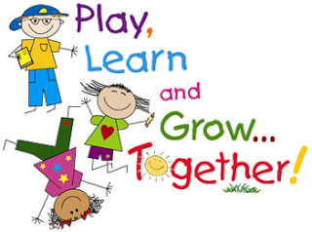
I would like to get to know your child better as we begin our school year. I will be bringing in a few artifacts from my life to share with the children so they get to know me better. I would be delighted if you could send a picture and write a letter about your special child so I can get to know them better from a different perspective. We will also be discussing summer holidays so pictures related to this would be very fun to see. We will be sharing on Friday, September 04, 2015. Attached is a form to help me learn more about your child, please fill it out and return it to help me understand more about your child.

I am excited to learn about all the children and have fun learning together this year. I will keep you informed of any new developments that emerge as the year unfolds. Thank you for praying for the grade 1/2 class, school, our principal, vice principal, support staff, and for me.

In Christ’s Service,

Jesselee Beauparlant
Grade One/Two Teacher
Cochrane Christian Academy
jbeauparlant@rockyview.ab.ca

